**Cloud Computing**

**Introduction:**

Cloud computing is a model for delivering computing services—such as servers, storage, databases, networking, software, and analytics—over the internet ("the cloud") on a pay-as-you-go basis.

Instead of investing in and maintaining physical data centers and servers, organizations can access these resources from cloud providers, allowing for scalability, flexibility, and cost-efficiency.

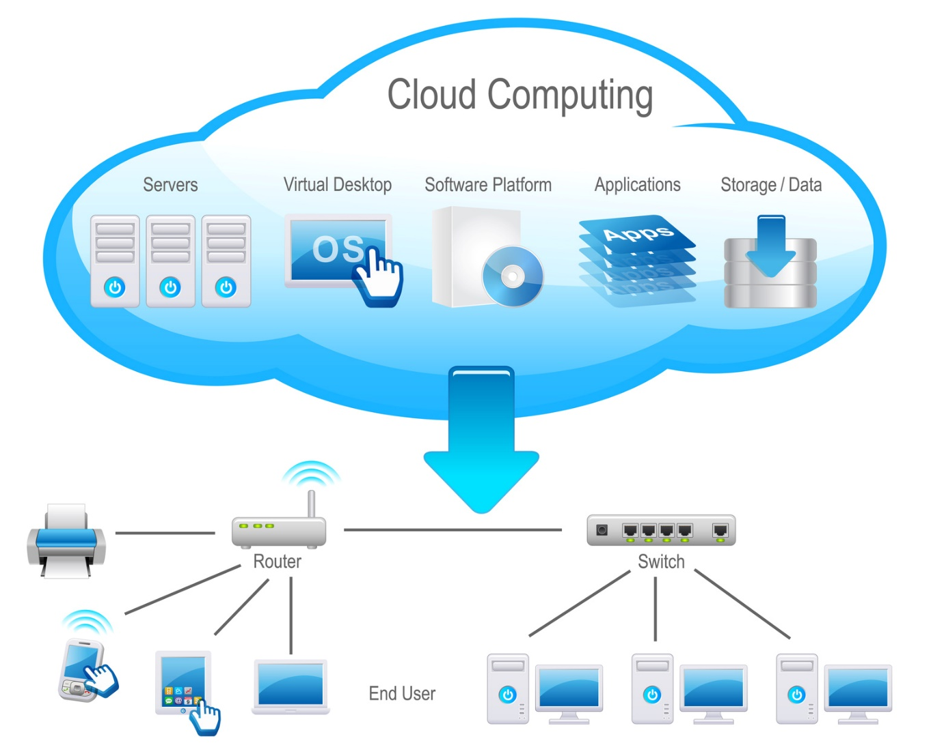

**Types of Cloud Computing:**

1. **Public Cloud** – Provided by third-party providers like AWS, Azure, Google Cloud
2. **Private Cloud** – Dedicated for one organization, offering better control and security
3. **Hybrid Cloud** – Combines public and private cloud to optimize performance

**Key Characteristics**

According to the National Institute of Standards and Technology (NIST), cloud computing exhibits five essential characteristics:

* **On-demand self-service**: Users can provision computing capabilities automatically without human intervention.
* **Broad network access**: Services are accessible over the network via standard mechanisms, promoting use by diverse client platforms.
* **Resource pooling**: Computing resources are pooled to serve multiple consumers, with resources dynamically assigned according to demand.
* **Rapid elasticity**: Capabilities can be elastically provisioned and released to scale rapidly outward and inward commensurate with demand.
* **Measured service**: Resource usage is monitored, controlled, and reported, providing transparency for both the provider and consumer.

**Service Models**

Cloud computing services are typically categorized into:

* **Infrastructure as a Service (IaaS)**: Provides virtualized computing resources over the internet. Users can rent servers, storage, and networking hardware, gaining control over the operating systems and deployed applications.
* **Platform as a Service (PaaS)**: Offers hardware and software tools over the internet, typically for application development. Users can develop, run, and manage applications without dealing with the underlying infrastructure.
* **Software as a Service (SaaS)**: Delivers software applications over the internet, on a subscription basis. Users can access applications via web browsers, eliminating the need for installations or maintenance.

**Deployment Models**

Cloud deployment models include:

* **Public Cloud**: Services are delivered over the public internet and shared across organizations. Examples include Amazon Web Services (AWS), Microsoft Azure, and Google Cloud Platform.
* **Private Cloud**: Services are maintained on a private network, offering greater control and security.
* **Hybrid Cloud**: Combines public and private clouds, allowing data and applications to be shared between them.

**1. Cost Savings**

Cloud computing eliminates the need for substantial upfront investments in hardware and infrastructure. Instead, it operates on a pay-as-you-go model, allowing businesses to pay only for the resources they use. This approach reduces capital expenditures and lowers operational costs.

**2. Scalability and Flexibility**

Cloud services offer the ability to scale resources up or down based on demand. This flexibility ensures that businesses can efficiently handle varying workloads without overprovisioning resources.

**3. Enhanced Security**

Leading cloud providers implement robust security measures, including data encryption, access controls, and regular security audits. These features help protect sensitive data and ensure compliance with industry standards.

**4. Accessibility and Mobility**

Cloud computing enables access to applications and data from any location with an internet connection. This mobility supports remote work and allows teams to collaborate effectively across different geographies.

**5. Improved Collaboration**

Cloud-based tools facilitate real-time collaboration by allowing multiple users to work on documents and projects simultaneously. This enhances productivity and streamlines communication within teams.

**6. Automatic Updates and Maintenance**

Cloud service providers handle routine maintenance and software updates, ensuring that systems are always up-to-date with the latest features and security patches. This reduces the burden on in-house IT teams.

**7. Business Continuity and Disaster Recovery**

Cloud computing offers reliable backup and disaster recovery solutions. In the event of data loss or system failure, businesses can quickly restore operations, minimizing downtime and data loss.

**8. Environmental Sustainability**

By optimizing resource utilization and reducing the need for physical hardware, cloud computing contributes to lower energy consumption and a smaller carbon footprint. This supports environmental sustainability initiatives.